KRC OTC experiment metadata

Construction: We constructed the OTCs following the standard design of the ITEX manual chapter 7: https://www.gvsu.edu/itex/library-8.htm. To elevate all OTCs ca. 8 cm above ground, we placed the hexagons of metal poles, specifically welded to hold the OTCs, and fasted them with thin wires.

Experimental design: After an initial trial in February 2024 (see below), we set up the experiment in January 2025 as follows: We set up a total of 36 open-top chambers (OTCs) in a hierarchical design that consists of 3 land-use types: KRR [natural], Johnny’s North [JN; low grazing/browsing intensity], and Jonny’s South [JS; high grazing/browsing intensity]. At each land-use types, we positioned 12 OTCs into driedoring stands, making sure that at least 1 juvenile driedoring is at the center of the plot. The OTCs were randomly assigned to one of 3 treatments (replicated in 4 sites): dung + dung beetles added to the OTC, only dung added, neither dung nor dung beetles in the OTCs. We also replicated all treatments using fences instead of OTCs, as well as open controls. All OTCs were separated by at least 50 m.
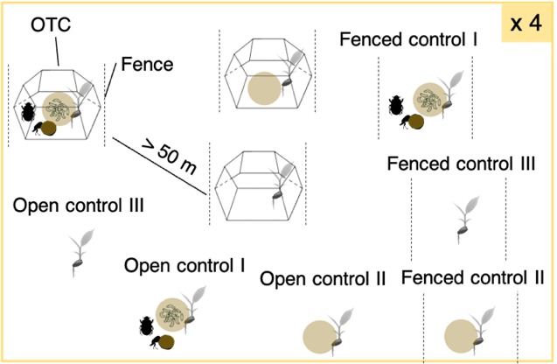
We set up the OTCs and fenced control 1 month prior to the start of the experiment, making sure no ungulates pass and deposit dung in the area.

SET-UP JANUARY 15-17 OF EXPERIMENTS

We set up the entire experimental design at 12 sites (4 KRR, JN, JS). The locations of the treatments can be found in OTC_KRC.kml (each location is named after the treatment replicate: no name – no dung nor dung beetles to be added; D – dung to be added; DDB – dung and dung beetles to be added). At each site, we randomly placed the 3 OTCs, 3 fenced controls, and 3 open controls. We placed the treatment units always at least 50 m apart, and with >1 juvenile driedoring in the center. We also placed 4 soil temperature/moisture loggers in KRR, JN, and JS (always one inside the OTC and one adjacent, as described above). We added those to the main logger data file.

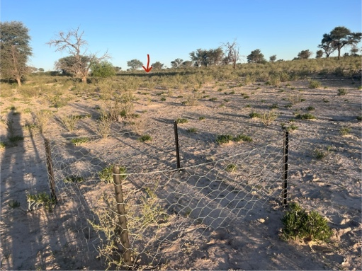
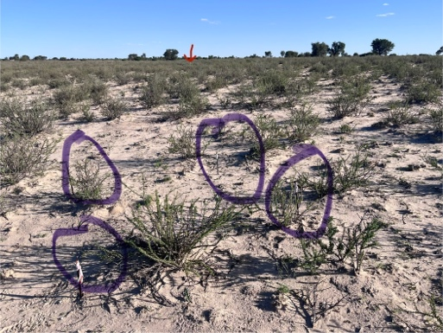
NOTE that I forgot to mark on open control point in JN1.

On the pictures above, we can see an example of a fenced control plot (the dimensions are 1.5mx1.5m and ca 1 m tall) and equivalent open control plot (with the poles circled in purple). The red arrow indicates the closest OTC.

The experimental procedure was as follows:

- Pre-Experiment Preparation

Prepare 144 dung balls, each weighing 500g. From these, 72 will be covered with mesh to prevent dung beetle activity, and 72 will remain uncovered to allow dung beetle activity.
Freeze all dung balls at least 48 hours prior to the experiment date.

- Preparation the Day Before the Experiment

Defrost the dung before placing it in the plots for at least 24h before deployment.
Ensure you have enough red filters lights ready for the evening session.

- Starting the Experiment - General Procedure

Two sessions per site will be carried out: one in the morning and one in the evening, to target both diurnal and nocturnal dung beetle species throughout the experiment.
Each day, the experiment will be conducted at 6 sites in total, by 3 groups, each responsible for 2 sites. Ideally, each group will consist of two people to reduce observation bias by statistical analysis.

All groups start deployment for both sites and focal at the same time (e.g., 19:30 for the evening session).
At each site, dung treatments are deployed in the corresponding OTC, Fence, and Open Control plots (no dung, dung with mesh, dung without mesh).
Once the first site is set up, each group moves to their second site and repeats the setup.
After completing the installation at both assigned sites, the group returns to the first site to begin observations.

- Observations

Two alternating observation rounds per site will be conducted to maximize the chance of capturing peak dung beetle activity.
Observation duration per site: 10 minutes per plot with exposed dung (no mesh), resulting in 30 minutes per site per round.
During the evening session, red-filtered lights will be used to minimize disturbance to natural beetle behavior, as dung beetles are attracted to white light.

Data to record for each plot with exposed dung:
- Date
- Time
- Site
- Structure type (OTC, Fence, Control)
- Total number of dung beetles arriving at the plot (only dung-feeding beetles observed arriving during the 10-minute observation period are counted. This includes beetles already on the dung when the observation period begins, as well as those emerging from pre-existing burrows near the dung during the observation period)
- Number of Escarabaeus satyrus individuals arriving
- Number of Scarabaeus proboscideus individuals arriving
- Number of Pachylomera femoralis individuals arriving
- Number of Pachylomera opaca individuals arriving
- Dung activity is measured by the number of dung balls created by beetles that remain within the plot (either because the beetle began burying them inside the plot or the ball stayed within the plot until the end of the 10-minute observation period). Dung activity is also recorded when endocoprid and paracoprid beetles arrive at the dung and perform dung-related activities on it.
- Number of dung balls made by beetles that left the plot before the end of the 10-minute observation period
- Whether dung beetle activity was present at the start of the observation period but without seeing the dung beetles
- Additional comments (for example, not if all dung was buried at the end of the session, etc.)

- Collecting dung:
After 10 days, we removed the mesh from the dung-only treatments and left the dung in the field. After 20 days, we collected all remaining dung from the plots, brought it to the lab and dried it at 70ºC for 24h, along with 3 control 500-g dung balls.

- Experiment Timeline in Kalahari Research Center 2025

Observations:
From: March 20th, 2025 (evening session)
To: March 22nd, 2025 (morning session)
Dung collection: April xx, 2025

Further data collection:

Soil analyses:

We took soil samples (ca. March 15, 2025) from a subset of sites and treatments (see soil-core-ID.xlsx) before the treatments but after the OTCs and controls were in place, and will repeat the sampling after 4 months. We measured the following:
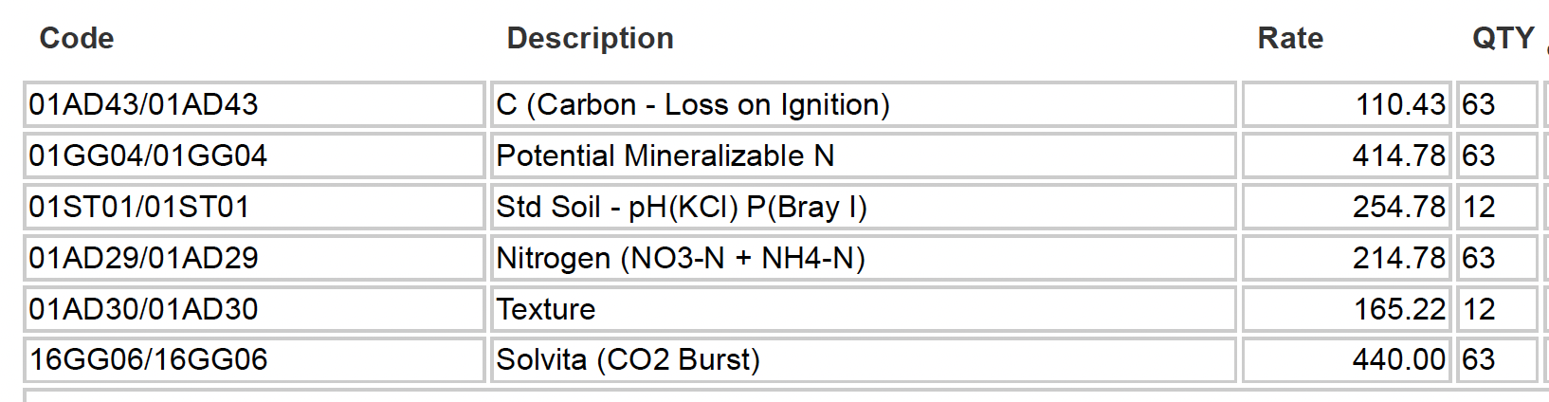

The experiment will run for 4-6 months and will be repeated in 2 years at least. After depositing dung, we will monitor it for 48 h (taking pictures of the dung every 12 h to see decomposition rates). At the beginning of the experiment, all driedoring within the OTCs will be individually marked and their vertical height (V) and horizontal width (H), as well as distance (D) to closest OTC wall from center of plant (0 if > 20 % of plant leaves are touching wall), will be determined:
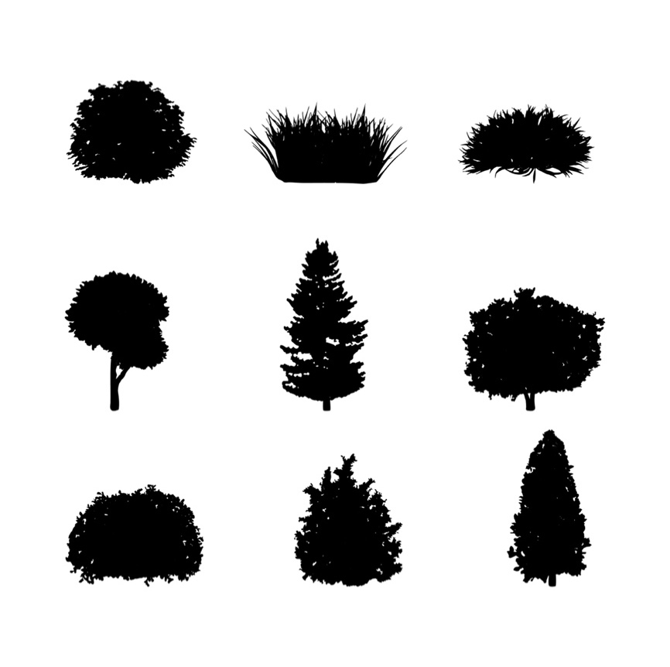
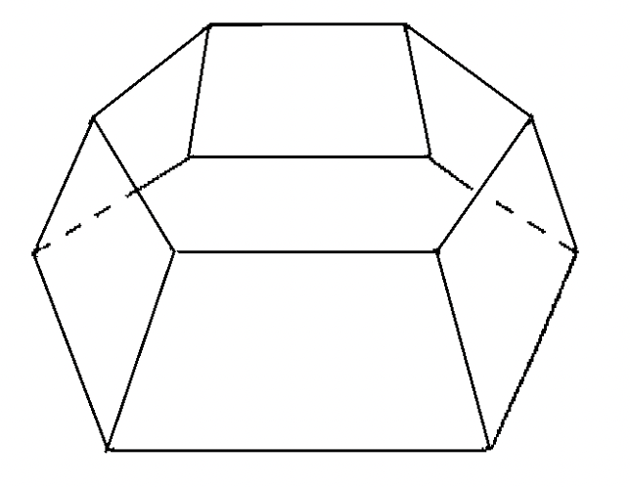
V
H
D

Driedoring Shrubs Measurement Protocol Metadata

All Driedoring shrubs (Rhigozum trichotomum) located within the OTCs, Fence and Control plots will be individually marked using color-coded bead combinations. The colors represent numerical values as follows: White = 0, Black = 1, Blue = 2, Lime Green = 3, Dark Green = 4, Yellow = 5, Orange = 7, Red = 8, Gold = 9. A shiny bead will be used to indicate the starting point from which the color combination should be read.

For each plant, the following measurements will be recorded: vertical height (V), horizontal width (H), and distance (D) from the center of the plant to the closest OTC or Fence wall. If more than 20% of the plant’s foliage is in contact with the wall, the distance (D) will be recorded as zero.

Due to the oblique shape of the OTC walls, the horizontal distance from the plant center to the wall depends on the height at which the measurement is taken. Therefore, the "zero" reference point is set at the apical edge of the OTC wall. Any Driedoring located beyond this limit (i.e., under the OTC wall) will be recorded with a distance (D) of zero.

If a Driedoring plant has its center located outside the plot but a branch extends into the plot, the plant will still be marked and measured. However, it will be clearly noted that its center is located outside the plot.

We will note percent cover of other vegetation (species level in each OTC).

Trials: On February 13-16, 2024, we set up initial trials of OTCs. We placed 2 OTCs at KRR, JN, and JS, along with one unmanipulated open control at each of the 3 sites. The locations of the OTCs and controls can be found in the file OTCs.kmz. We did not fence the plots prior to placing the OTCs or controls, but we ensured that dung was not present in any of the locations. We tagged and measured the size of all driedoring in the plots and described vegetation cover as described above (see OTC_vegetation_csv). On February 14 in the afternoon, we placed ca. 500 g of fresh dung in OTC 1 at each site, finishing at sunset. We repeated this starting at dawn of February 15. We also placed one TOMST soil moisture and temperature logger (https://tomst.com/web/en/systems/tms/tms-4/) in the OTC 1 at KRR, and another logger outside the same OTC.

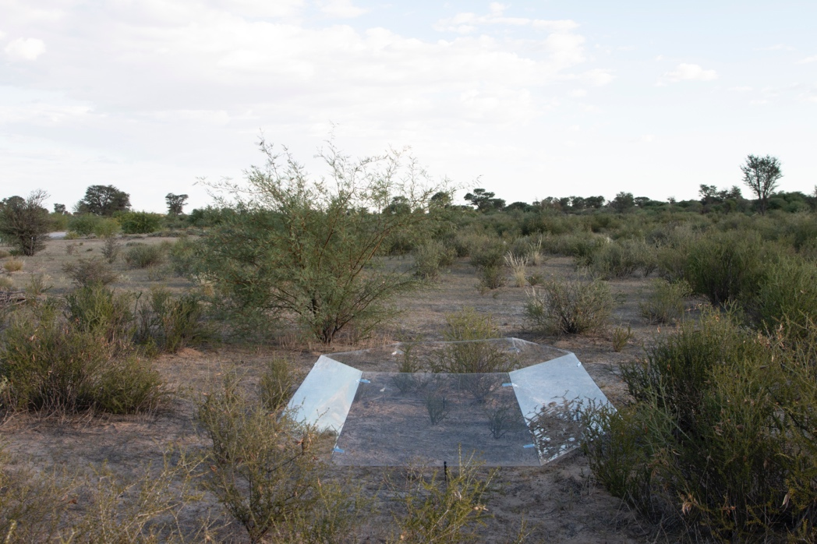

Data collection of trials: The vegetation in the trial plots has to be followed monthly as described above. The data from the loggers has to be retrieved monthly as well. We took pictures of the dung deposited on Feb 14 at deposition and after 12 h (morning of Feb 15):

JS (Feb 14) (Feb 15) (Feb 15, with new)
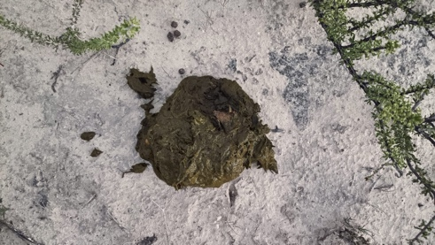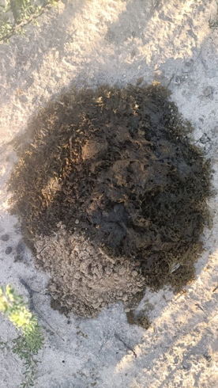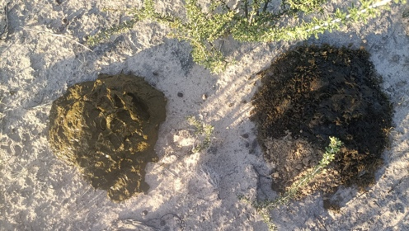

JN (Feb 14) (Feb 15) (Feb 15, with new)
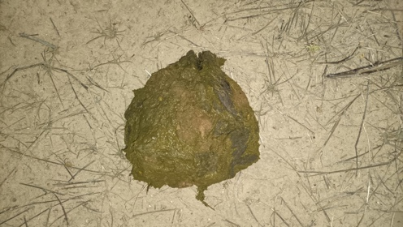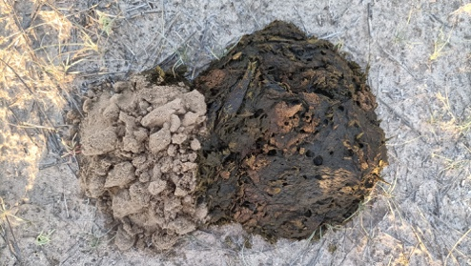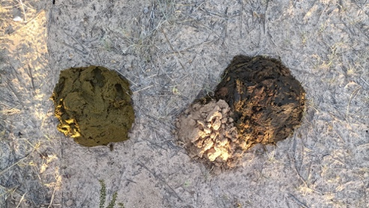

KRR (Feb 14) (Feb 15) (Feb 15, with new)
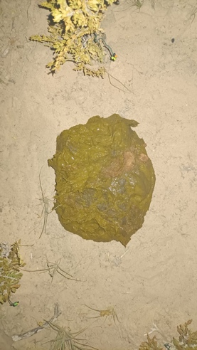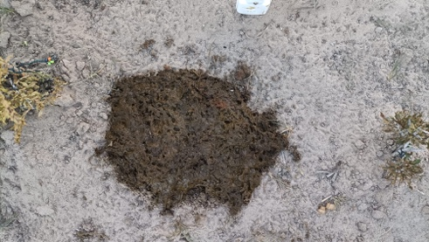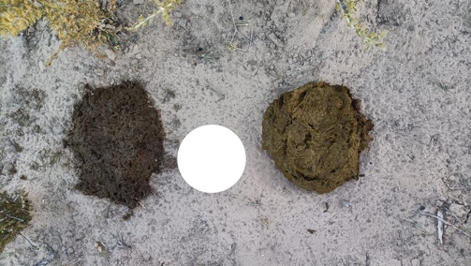

Data files:

We recorded the location of all trial OTCs and controls as OTCs.kmz.
We recorded the vegetation in all trial OTCs and controls in OTC_vegetation_csv.

The driedoring data from the trials can be found in OTC_vegetation_csv. We will then monitor the driedoring individuals monthly, as well as record vegetation composition. We will also take a fixed photograph of the experimental plots, to help with assessments of vegetation cover.

To do February 2025:

- Mark and measure all drie doring and % vegetation cover
- Take soil samples
- Implement the experiment:
- Get dung, make 500-g balls (you’ll need 72 balls for the morning treatment, and 72 for the evening);
- freeze balls;
- Take another 3 samples of 500-g dung and dry them in the oven to estimate dry mass;
- You will do the experiments for 48 h consecutive hours, on two days with similar ambient conditions
- On day 1 at sunrise, place dung in respective treatments in 2 sites per land-use type. Cover the dung-only treatments with mesh, allow dung beetles to enter the dung + dung beetle treatments.
- There will be a minimum of 1 observer per site, who does 15-min observations of dung beetles on the dung, rotating among treatment units (doing this for a total of 2 h)
- Repeat the experiment at sunset

